# Data Analytics with Tableau

## Monday (2/28/2022)

### Discuss Homework Assignment

The future is so bright you gotta wear shades!



### Data Mining/Analytics Methodology

Let’s see about adding to your repertoire of storytelling apparatus.

The Cross Industry Standard Process for Data Mining (CRISP-DM) is a well-known industry standard that has stood the test of time for putting together valuable insights from an opportunity presented in a business setting with a vast wealth of information. Slide – CRISP-DM Diagram.

As you are aware, the CRISP-DM standard is comprised of six major phases, from which we will use a slight variation as follows:

* Business Relevance
* Data Understanding
* Data Preparation
* Modeling / Data Analytics
* Evaluation
* Deployment

We are not going to delve into building statistical models, but instead we are going to study the finer techniques of data analytics to drive out actionable insights.

There are several exceptionally good reference websites for review at your leisure:

<https://www.datascience-pm.com/crisp-dm-2/>

<https://agilethought.com/blogs/scaling-data-science-use-crisp-dm-agile/>

<https://towardsdatascience.com/why-using-crisp-dm-will-make-you-a-better-data-scientist-66efe5b72686>

This chart gives a sense of the steps within each phase, deliverables and a view that connects the flow of work to produce results that meet/exceed a customer’s expectations.

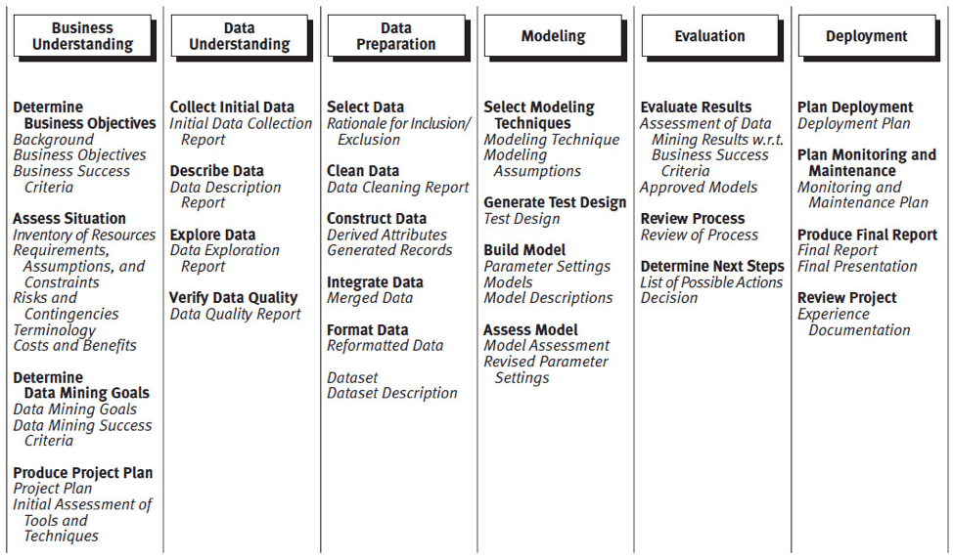

The substitution of Data Analytics or Modeling looks as follows:

**Story Telling**

*Define Opportunity*

*Determine Analysis to Act*

*Enticement with Results*

*Forecast “What If”*

*Compare to “What Was”*

**Data Visualization Methods**

*Construct Charts/Graphs to Illustrate Story*

*Annotation that Breathes Life*

*Is the Story a Best Seller?*

**Assess Results**

*Alternative Approach to Results*

*Cross Reference Results at Various Dimensions*

*Articulate Confidence in Results*

### Review of Business Relevance and Data Understanding of your CRISP-DMs.

Each student will have a chance to walk through their CRISP-DM, review with the class their idea for the capstone, discuss the tasks necessary for getting a very good understanding of their data, and present any working code or other statistical details. The class will then lend a hand with respect to any questions or shortcomings each student has with respect to the first set of deliverables.

### Capstone Discussion

Is your topic still interesting after delving into various sets of data that might be applicable to your analysis?

The next step is the start the manipulation of your data as outlined in the Data Preparation stage of the CRISP-DM. We will look at my completed example, talk about the computations and other aspects of wrangling my data from the MLB teams and then answer any questions you all might have about the next step in the process of putting together the final deliverables for Demo Day.

GOAL – Development of a stellar presentation for Demo Day as we are learning the skills necessary for Data Analytics.

Thoughts?